A Further Look at Operating System Choice

Joseph Parsons

josephtparsons@gmail.com

One thing I glossed over in the second part of my PC building resource (available at http://themetropolitan.metrostate.edu) is operating system choice. For most people, the best operating system will simply be the latest version of Windows, but there are actually a lot of factors one could weigh in deciding which operating system to use. Indeed, the glory of a PC is that it can run many different operating systems, or even multiples at once. I’d like to take a look at the most popular operating systems available, and weigh the pros and cons of each.

## Windows XP

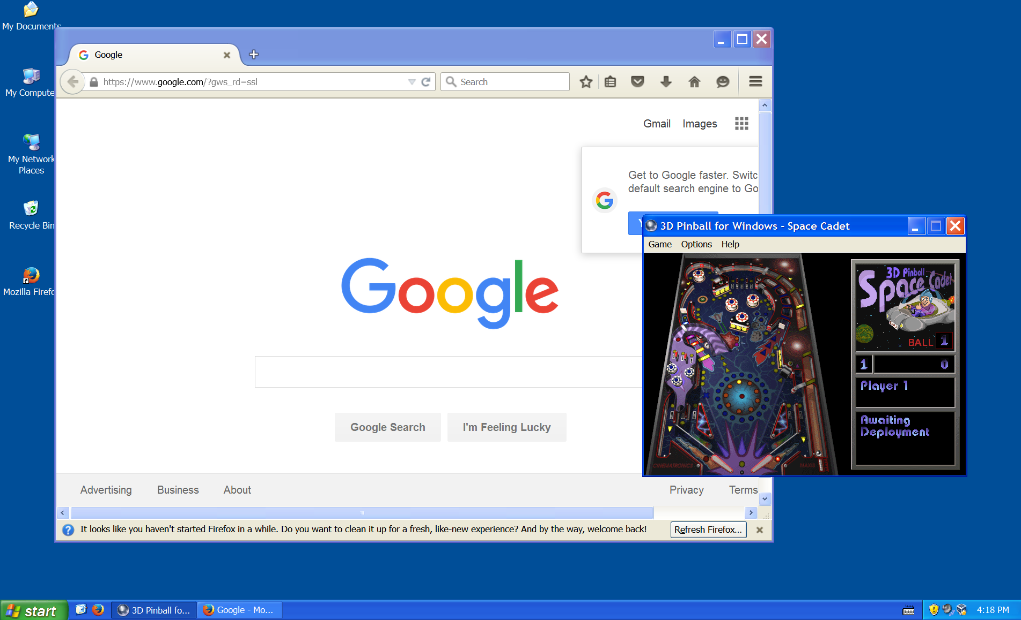

Caption: Windows XP sure is nostalgic, but you shouldn’t be using it.

Don’t use it. I don’t think anyone does use it anymore, but just in case: Windows XP no longer receives security updates, and is thus insecure. You could, if you want, install Windows XP in a virtual machine, which I may try to explain in-depth a future article, but it should absolutely not be your main OS.

## Windows 7

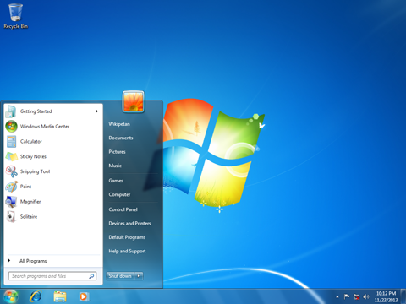

Caption: Windows 7 is also kind of nostalgic, and you can actually get away with using it!

Windows 7 has some advantages over the newer Windows 10. It’s less privacy-intrusive, more refined and stable, more compatible with some older Windows applications and, as a whole, *still works*.

But, it will stop working. Microsoft’s general support for Windows 7 ended in 2015, meaning that new Windows technologies (like DirectX 12, used in some of the newest games) will not be coming to the seven-year-old OS. It will continue to receive security updates until 2020, and EMET continues to be supported, so Windows 7 will remain secure for at least a few more years. After that? It will become a virus wonderland.

To make that timetable even more imminent, Microsoft is going to stop releasing most security updates in July 2017 for Intel’s 6th generation “Skylake” chips (which includes all 6xxx chips). And it won’t be releasing *any* security updates for the currently unreleased 7th generation “Kaby Lake” chips, or the unreleased AMD Zen chips. It is possible that the operating system will still work on these newer chips, but Microsoft makes no guarantees. Thus, most users should avoid Windows 7 entirely if they’re running the very latest Intel or AMD processors.

## Windows 10

## 

Caption: The Windows 10 start menu, courtesy of The Verge

Windows 10 is Microsoft’s latest Windows iteration. On the whole, it’s a good operating system: compatible with the usual Windows programs, low system requirements, high built-in security, and a lot of features to try and make your workflow easier.

It comes with three big drawbacks, however:

-It invades your privacy.

-It is still somewhat buggy compared to Windows 7, even a year after its release.

-It can be very pushy; for instance, it may install updates without giving you a chance to stop it.

Windows 10 is your best bet if you don’t have any major objection to these, but if you do, Windows Server, Windows 7, and Linux all deserve a hard look.

## Windows Server

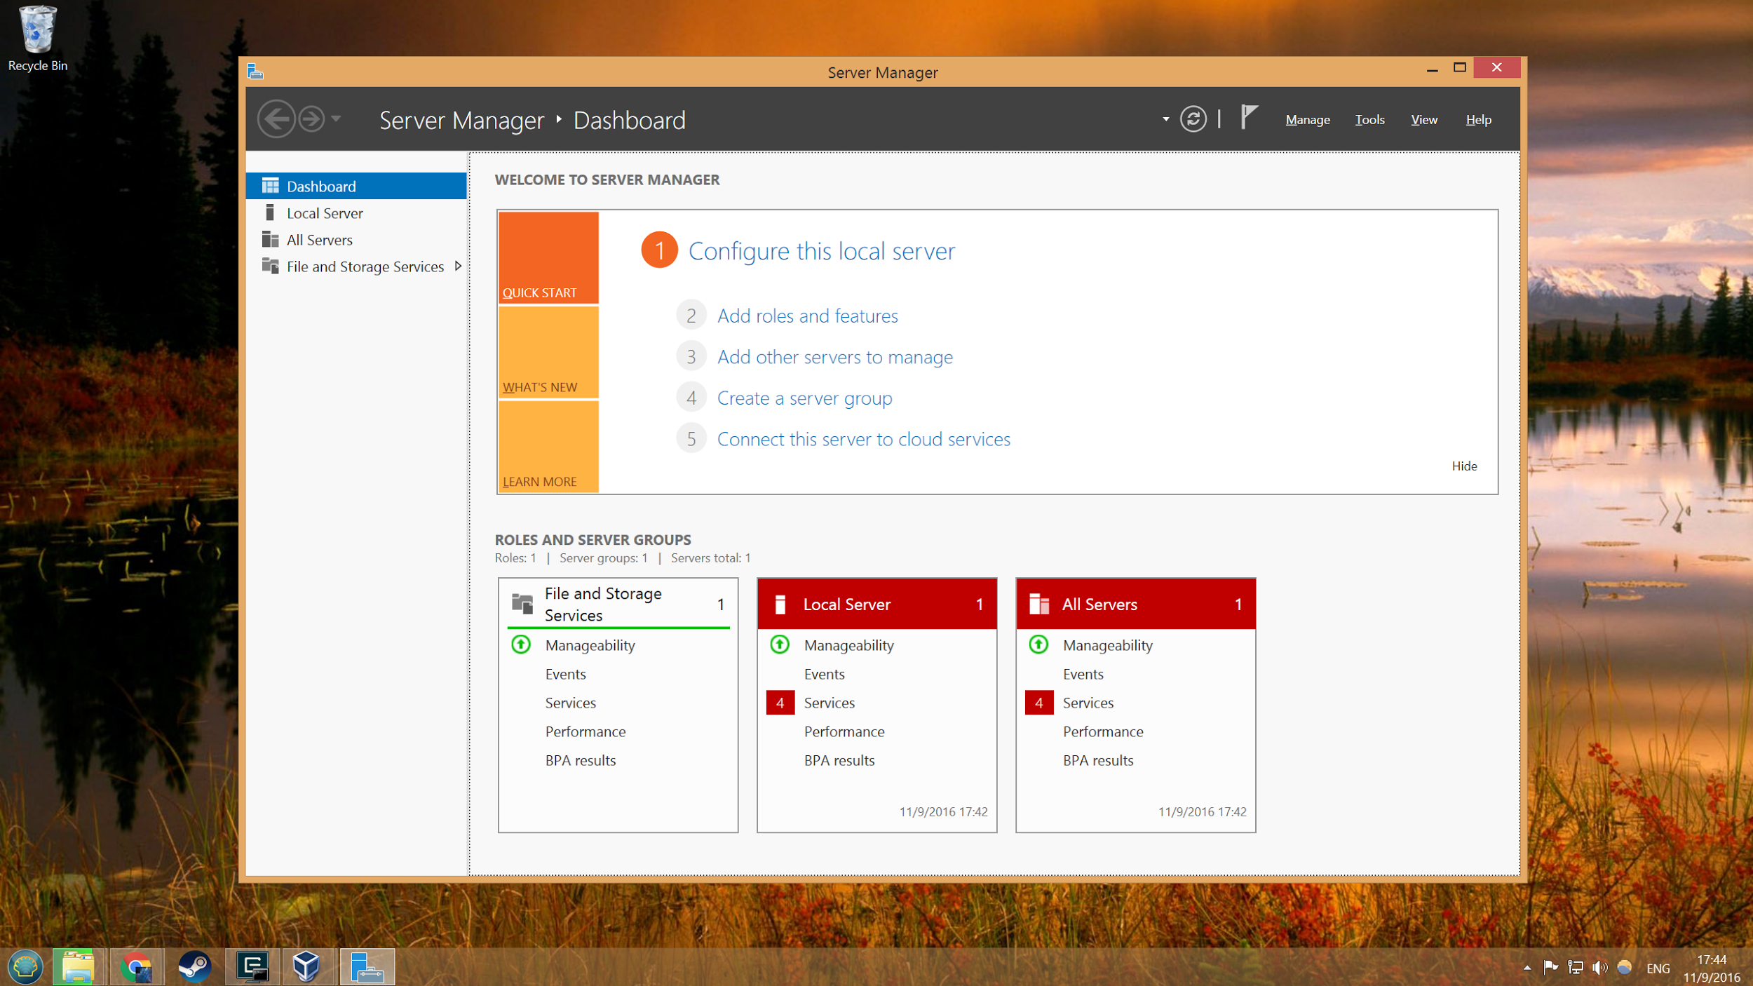

Caption: Ignoring the Server Manager, the Windows Server 2012 R2 desktop shown here is nearly identical to Windows 8.1’s.

I’ve mentioned Windows Server before as an alternative to consumer Windows. Windows Server is functionally almost identical to its corresponding consumer Windows version (Server 2012 R2 = Windows 8.1, Server 2016 = Windows 10), but without some of the more intrusive privacy features. Many students can get it for free from Microsoft Imagine (formerly known as DreamSpark), too!

As for drawbacks, it has two:

-Windows Server is slightly harder to install.

-Windows Server supports slightly fewer applications; for instance, it doesn’t support Bluetooth.

But, ultimately, the only big reason to consider it is if you plan on using your computer in some way as a server, be it as a file server, media server, or web server.

## Linux

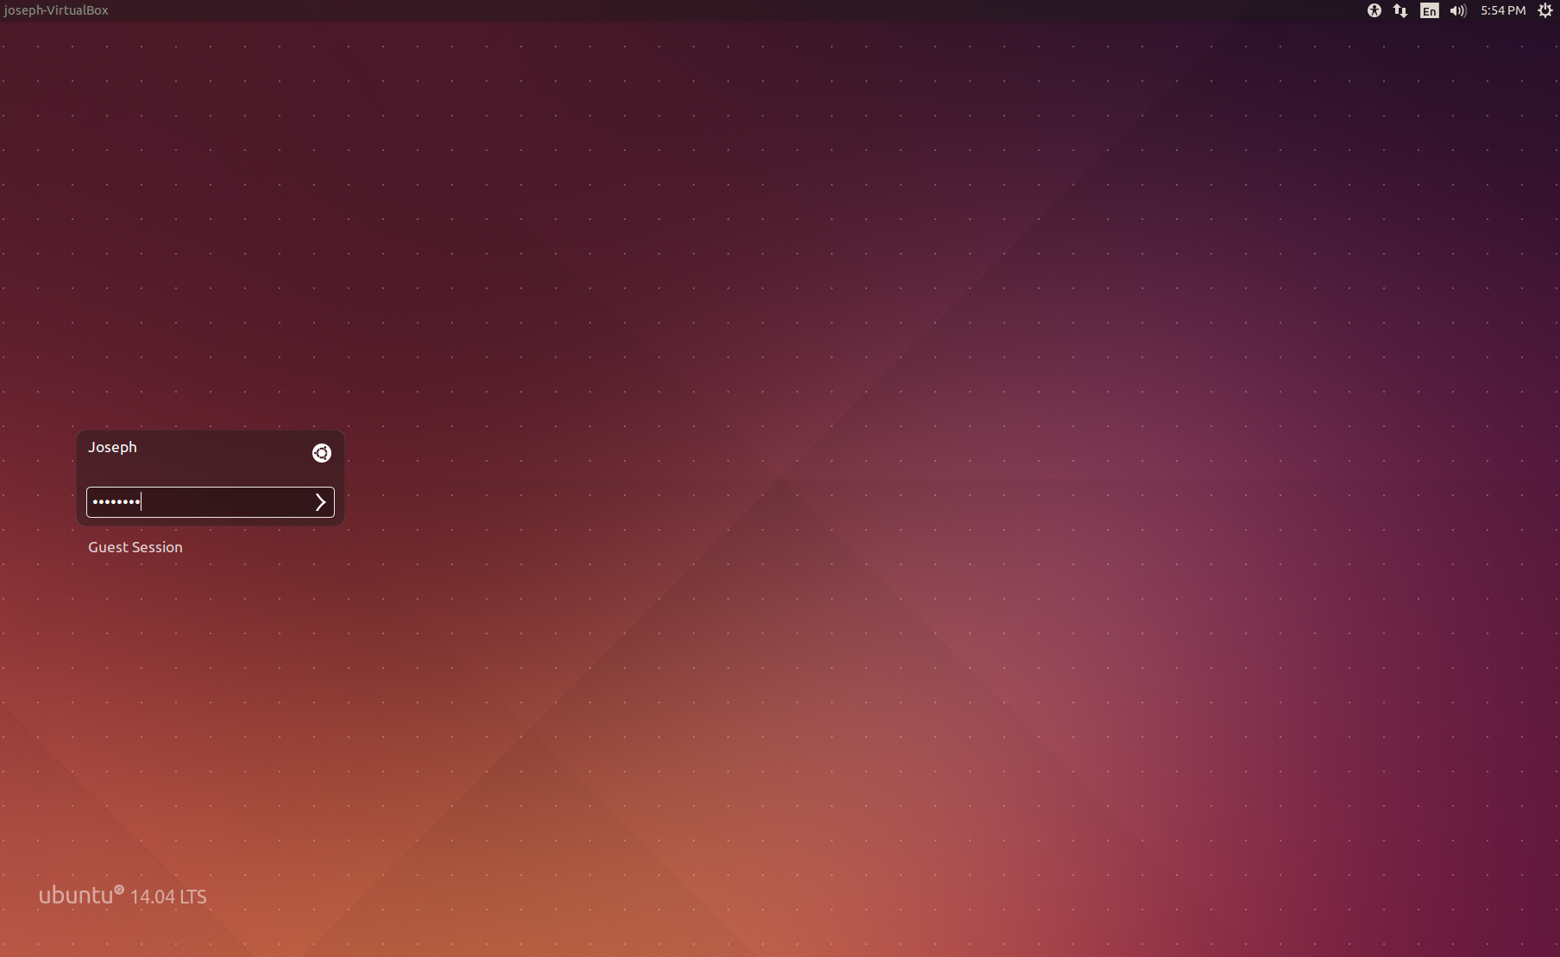

Caption: The Ubuntu Linux login screen

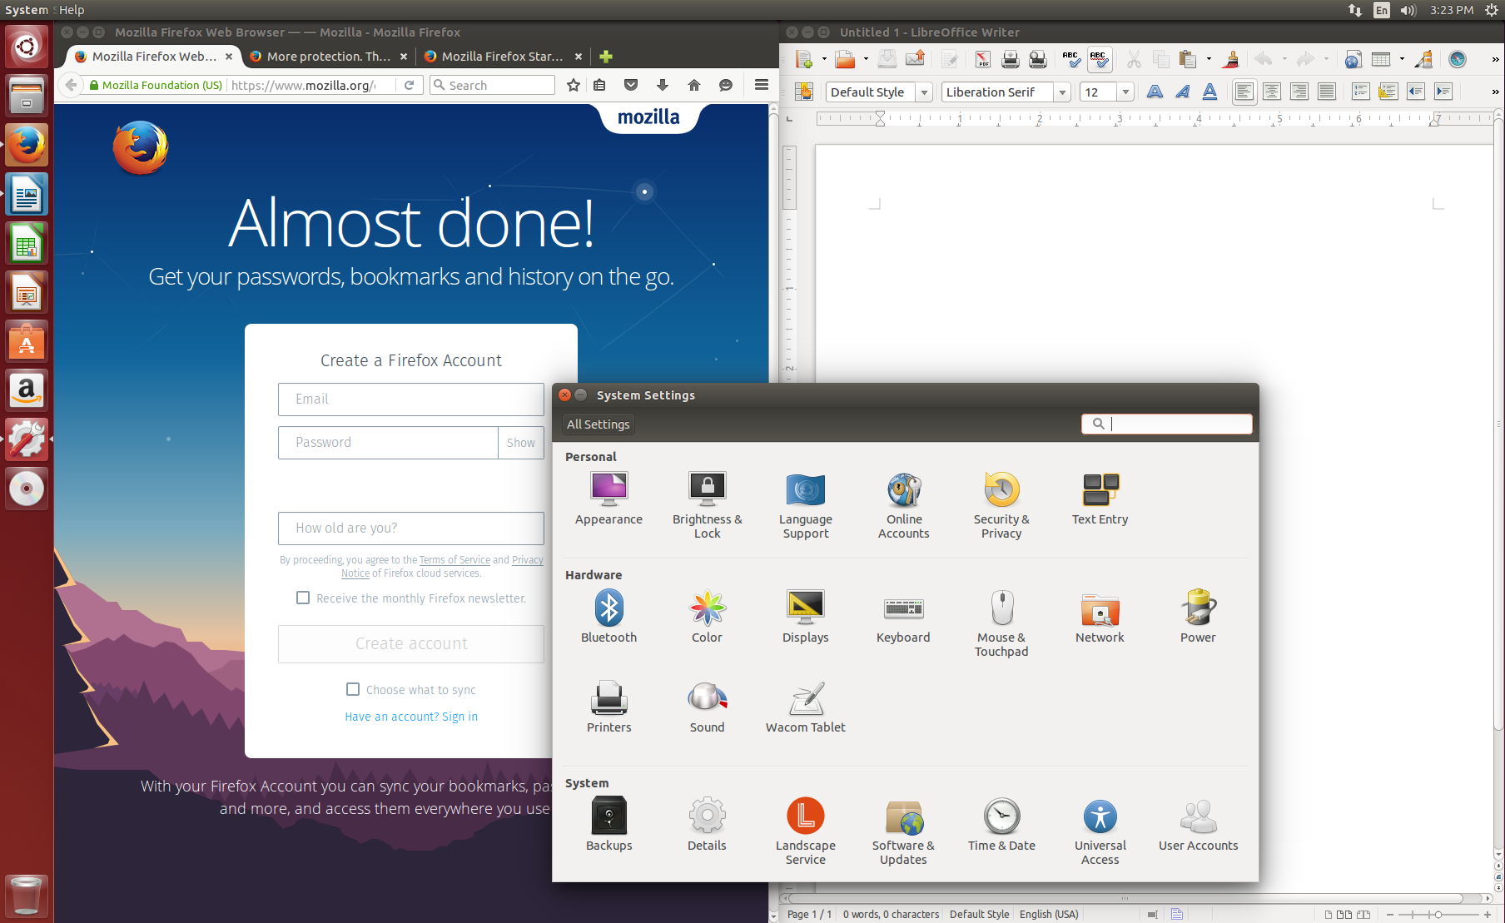

Caption: Running a freshly-installed copy of Ubuntu Linux with its default Unity Desktop Environment.

Linux deserves an article of its own, and I may eventually write one. But, for now, I’ll give you a brief overview of how Linux is different from Windows, why you might consider using it, and why you might want to stay away from it.

**The Difference**

Linux, under the hood, has far more in common with macOS than it does with Windows. These architectural differences often don’t matter, but they do manifest themselves in some interesting ways:

-Linux, at its core, uses only a text-based console. As a result, Linux variants all provide completely decoupled “desktop environments” (that is, the graphical interface for window management). There are three big desktop environments, Unity, Gnome, and KDE, and users can choose from whichever they like most.

-Until recent releases of Windows, Linux was *fundamentally* more secure than Windows. This was for the simple reason that Linux was originally designed to have multiple users, while Windows was designed with only one user in mind. Microsoft mostly fixed this in Windows Vista (it’s why the upgrade from XP to Vista was so painful), but even today Linux’s model occasionally results in better security.

The biggest difference, though, is that Linux is just a base. When you install Linux, you will be installing a custom Linux distribution (often known as “distros”) that provides all the user-facing applications and other modern conveniences. I generally recommend Ubuntu for these, but Linux Mint and Arch Linux are also good choices for new users.

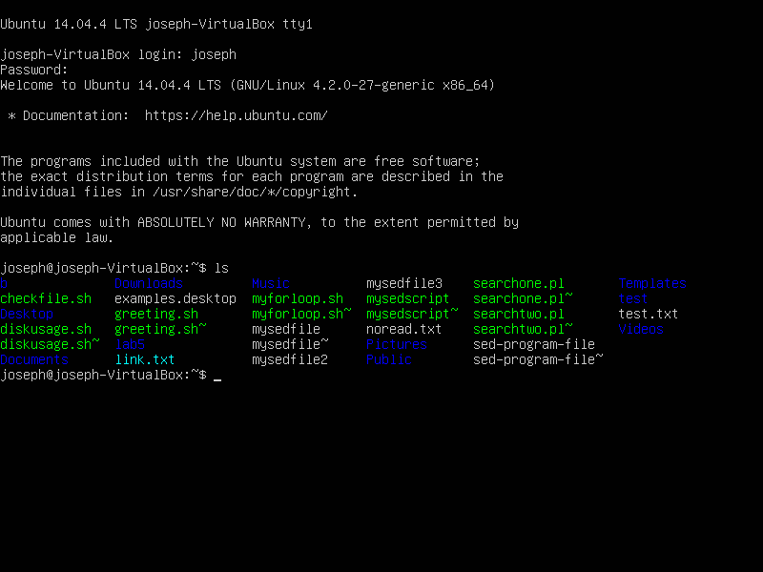

Caption: Without a desktop environment, Linux is just a console. You probably won’t ever have to use it, though.

**Why?**

In general, the simplest reason for many people is one of cost: you don’t have to pay for Linux.

But this isn’t really a good reason, and most people who use Linux wouldn’t be against paying for Windows. Rather, there’s five fundamental reasons to use Linux instead of Windows:

-It is open-source. This doesn’t matter for most people, but it has some interesting implications: if you want, you can modify the operating system’s programming code directly, and you can be certain about what the code running on your system is doing. It’s ultimately all about trust: by being open-source, you can trust that other users have verified the operating system, and it won’t be doing anything sneaky behind your back.

-It is flexible: just like you can change which desktop environment you use, you can change just about every component of the operating system. And if you have an old computer, you can still run modern Linux with a low-requirement desktop environment.

-It is powerful: Linux is an operating system for power users, especially application developers. It tries to stay out of your way.

-It is fast: Linux is the base of all Android phones, and is also used in many small devices. This necessitates that it be as fast as possible.

-It is small: much as Linux needs to be fast to support smaller devices, it also needs to be small. Ubuntu Linux, which comes with a full office suite and desktop environment, installs fresh to only about 4GB of space. Windows 10 needs at least 20GB.

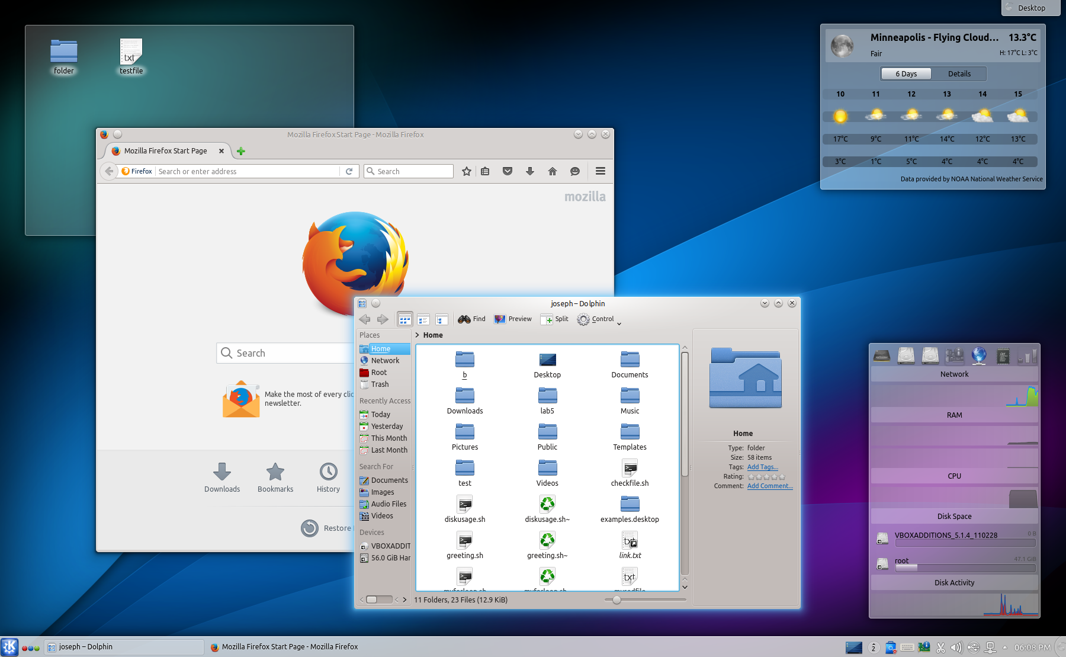

Caption: Ubuntu Linux with the K Desktop Environment (KDE), my personal DE of choice.

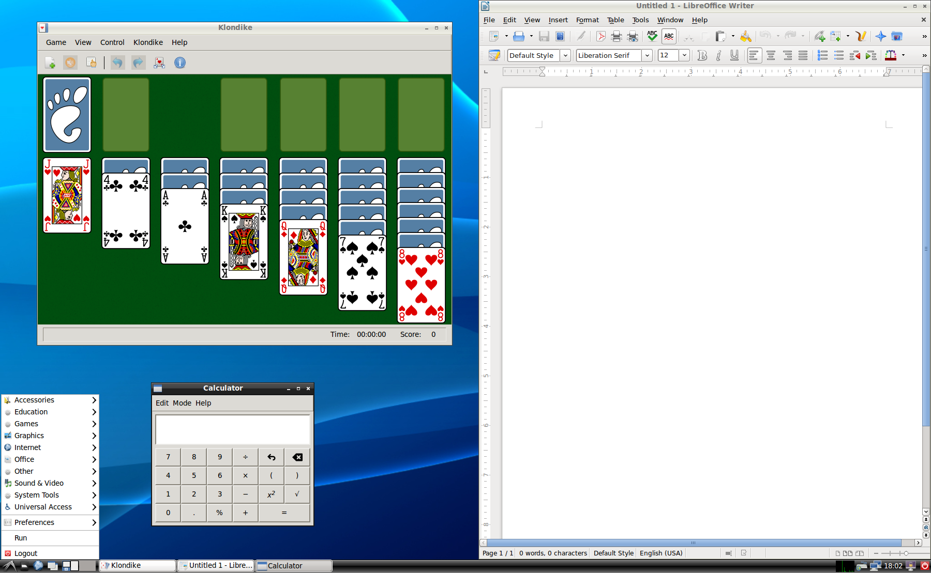

Caption: Ubuntu Linux with the ultralight LX Desktop Environment (LXDE), capable of running on almost any PC.

**Why Not?**

Well, Linux certainly has an early learning curve for users who have only ever used Windows. Almost anyone, with enough patience, can download and install Linux on their computer. But learning its idiosyncrasies takes time, and Linux is often less user-friendly than Windows in very subtle ways.

Many applications don’t support Linux, either. While Firefox and Chrome are available for Linux, Microsoft Office, the Adobe Creative Suite, and most other professional software are not. Alternatives exist, like LibreOffice for Microsoft Office and GIMP for Photoshop, but they aren’t as powerful and can be harder to use.

A compatibility layer, called Wine, exists to allow Linux to run Windows programs, but it can be difficult to set-up, often doesn’t work, and is rarely usable for gaming. A more advanced solution is to run these applications through Windows virtual machines, but this also requires a lot of setup, owning a copy of Windows, and a lot more computer memory and hard-drive space. You can also run games through a virtual machine, but doing so requires a modern CPU and even more set-up, something that is hard to recommend to most people.

## Hackintosh: macOS

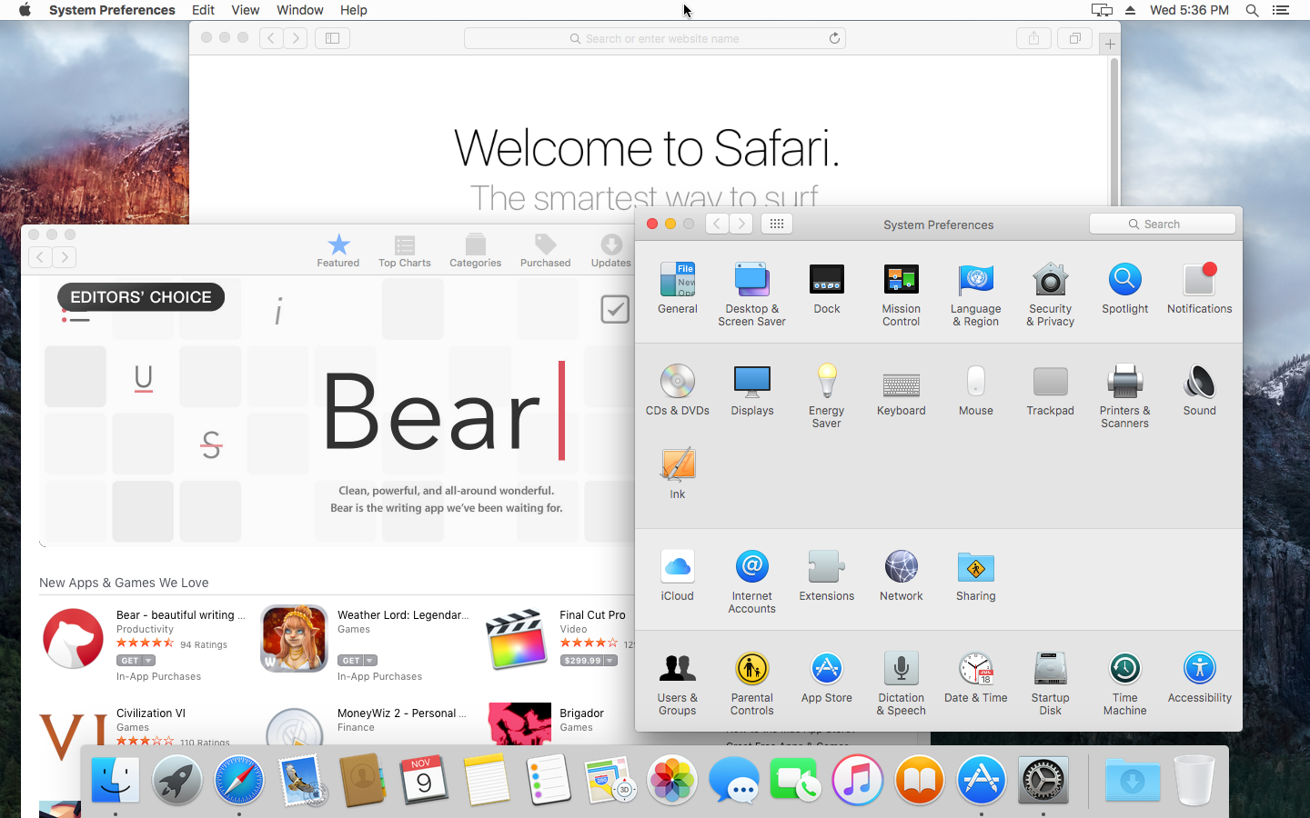

Caption: It is possible to install macOS on a PC, but may not be advisable.

I do feel it is worth mentioning that Apple lovers may rejoice in knowing that, with a bit of work, it is often possible to install macOS on a PC using software called OSx86. Unfortunately, it might not be legal. The macOS software license forbids users from installing macOS on non-Apple computers, and the Digital Millenium Copyright Law makes it illegal to circumvent the software mechanisms Apple uses to prevent PC installations of macOS.

Additionally, even ignoring the legal ramifications, driver support (for things like cameras and wireless cards) is buggy at best. So macOS is really only a good choice for the especially dedicated users.